Cn5000 lab 9

My first screenshot shows the FacebookEmojiCounter class component, which handles emoji counters for "Like," "Love," and "happy." The constructor initializes the component's state (number: 0) and binds the increment method. Emojis are stored in this.pic based on the type prop. The render method displays a button with the emoji and a counter that increments on button click.

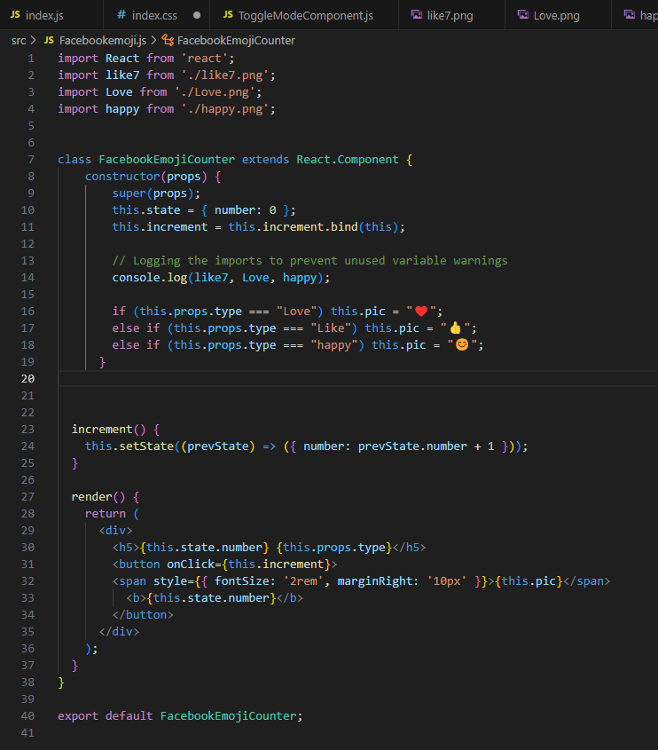

This image displays the ToggleMode class component, which toggles between "happy" and "sad" emojis on each button click. The constructor sets the initial emoji state as "happy" (😊) and binds the Toggle_Mode method. The Toggle_Mode method switches the emoji in this.state.pic between 😊 and 😢. The render method outputs a button that displays the current emoj

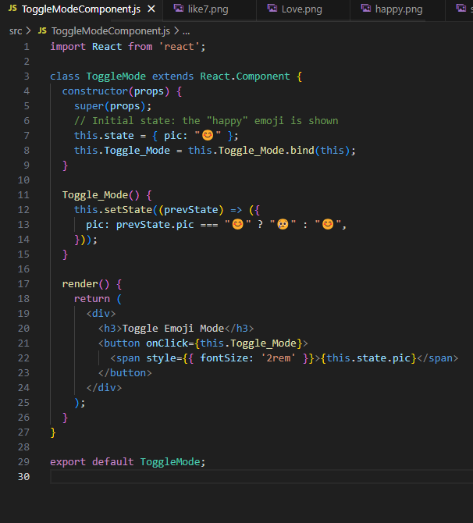

The index.js file is where the React app's components are rendered into the DOM. It imports FacebookEmojiCounter and ToggleMode components and renders them within a <React.Fragment> wrapper. Each FacebookEmojiCounter is passed a type prop ("Like," "Love," or "happy"), and the ToggleMode component is displayed below.

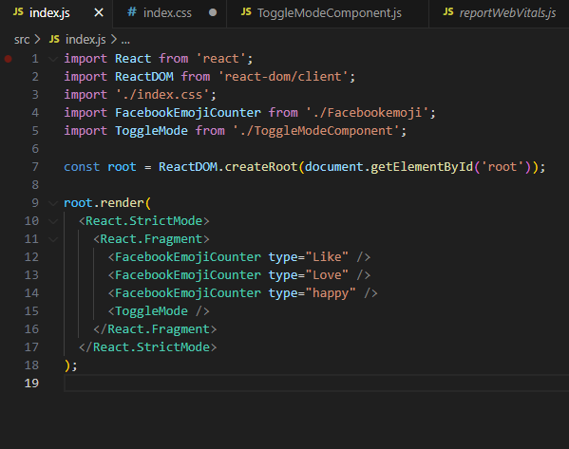

This is the initial state of the app. Three buttons display "Like," "Love," and "happy" emojis with a counter starting at 0. Below these is a toggle button showing the "happy" emoji (😊). None of the buttons have been clicked yet.

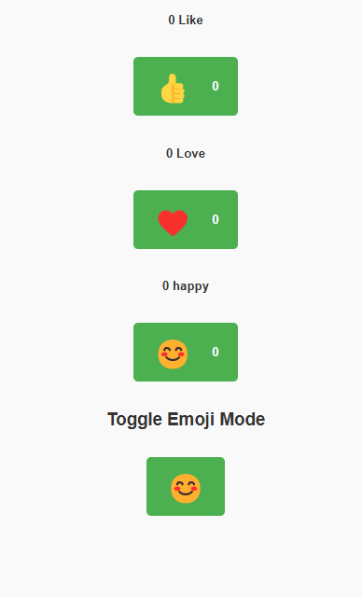

This image shows the app after clicking the "Like," "Love," and "happy" buttons once each. The counters next to the emojis have increased to 1, confirming the functionality of the increment method in FacebookEmojiCounter.

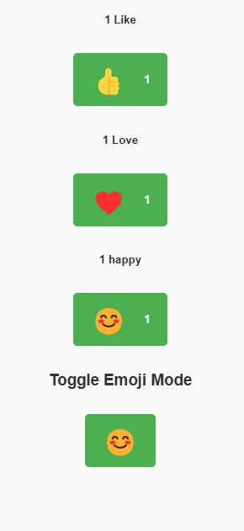

Lasty, below is the result of clicking the toggle button. The emoji has switched from "happy" (😊) to "sad" (😢), demonstrating the functionality of the Toggle_Mode method in ToggleMode.

